We need your time and your participation!

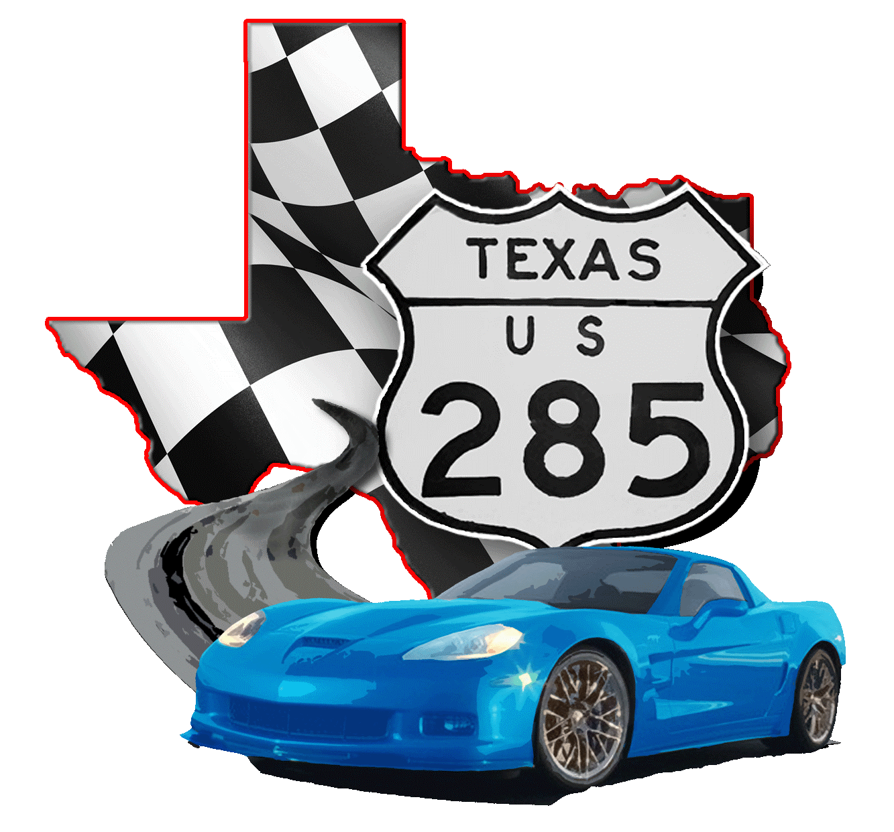
Pecos County Community Action Agency and
Big Bend Open Road Race Participants present the
2022 Head Start Cardboard Car Race
Friday, April 22 -- 9:30 to 11:30 am
Zero Stone Park, 400 S Nelson St, Fort Stockton, TX 79735

Head Start is a federally funded program that serves low income children 3-4 years of age, children with disabilities, and their families. Head Start recognizes that both mothers and fathers play an essential role in the healthy development of children. Children do best in life when they grow up with the active, positive involvement of both a mother and father.

Approximately 15+ years ago, the PCCAA Head Start Program began a Male Involvement Week of Activities which included Cardboard Cars. Students and their dads (uncles, grandpas, brothers, and friends) are instructed to make a car out of a cardboard box. It is decorated however the family chooses, however the child must be able to “wear” the car in the Car Parade.

This is where the racers at the Big Bend Open Road Race stepped up to help. BBORR racers were invited to join in on the car parade which begins at the Head Start School (600 South Young Street) and ends at Zero Stone Park. It wasn’t long before BBORR participants volunteered to help setup the activity, provide the kids with free tee shirts, act as judges for the car entries and hand out trophies, ribbons and lots of smiles. The Fort Stockton Police get in on the fun too – they block off the street between the school and the park for the parade and they get front row seats!

Over the years the support from all those involved with the Big Bend Open Road Race has been tremendous and greatly appreciated! The students and parents enjoy seeing all the BBORR race cars and racers love seeing the children’s cars as well. The PCCAA Head Start Car Show & Parade is held on Friday during BBORR week beginning at 9:30am and finishing at 11:30am.

We need more volunteers and race cars to participate in the Friday parade from the school to the park and to act as judges for the cardboard car entries. We don’t need monetary donations – just your time and willingness to help these kids learn about caring and compassionate communities.

Contact Russell and Sandra Brown if you can give us a hand and run your race car, help with setup, judging, handing out awards or just standing in the crowd and cheering loudly.
One of our little racers from the early years.

Call 512-826-4885 (Russell’s cell) or 512-789-5001 (Sandra’s cell-she’s the really nice one) or email us at rstxhome@gmail.com

